# Sound, Sensors and Crypto Test 2

What does C highlight in the diagram below?

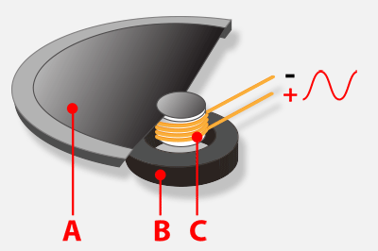

A. Cone

B. Current

C. Magnet

D. Sound wave

ANSWER: B

The code below has been used to store the names of people attending a club in Python. What is the name of the data structure?

**tune = ["Peter", "Paul", ”Paula”, ”Priscilla”]**

A. List

B. Array

C. String

D. Variable

ANSWER: A

What would the following code output?

supper = [“hot chocolate”, “toast”, “jam”, ”banana”]

print (shopping[1])

A. shopping[1]

B. Error

C. toast

D. hot chocolate

ANSWER: C

Sam has taken a sample of her voice and increased the pitch. What impact does this have?

A. She speaks quicker

B. Her voice is higher

C. Her voice is lower

D. Her voice sounds more tense

ANSWER: B

In order for the microbit to talk a module has to be imported. What is the name of the module?

A. Speak

B. Speech

C. Talk

D. Vocal

ANSWER: B

When you purchase a product over the internet the data is encrypted. What is the purpose of encryption?

A. To stop people stealing data

B. To stop people from understanding intercepted data

C. To allow data to be sent over the Internet

D. To stop people intercepting data

ANSWER: B

The Caesar cipher shifts letters along the alphabet. With a left shift of 2, what would the cipher text be for ‘code’?

A. eqfg

B. EQFG

C. ambc

D. AMBC

ANSWER: C

Using the key below, what would the message ’19 22 8 3 26’ be?

|  |  |  |  |  |  |  |  |  |  |  |  |  |
| --- | --- | --- | --- | --- | --- | --- | --- | --- | --- | --- | --- | --- |
| **A** | **B** | **C** | **D** | **E** | **F** | **G** | **H** | **I** | **J** | **K** | **L** | **M** |
| 2 | 3 | 4 | 5 | 6 | 7 | 8 | 9 | 10 | 11 | 12 | 13 | 14 |

|  |  |  |  |  |  |  |  |  |  |  |  |  |
| --- | --- | --- | --- | --- | --- | --- | --- | --- | --- | --- | --- | --- |
| **N** | **O** | **P** | **Q** | **R** | **S** | **T** | **U** | **V** | **W** | **X** | **Y** | **Z** |
| 15 | 16 | 17 | 18 | 19 | 20 | 21 | 22 | 23 | 24 | 25 | 26 | 1 |

A. 21 24 10 5 28

B. RUGBY

C. rugby

D. 17 20 6 1 24

ANSWER: B

What is the name of the highlighted sensor which uses an electrode hitting the right hand side to determine a right tilt?



A. Compass

B. Accelerometer

C. Tilt switch

D. Electrode sensor

ANSWER: B

What is the name of the sensor which is built into the microbit which can tell the direction you are facing?

A. Temperature

B. GPS

C. Direction

D. Compass

ANSWER: D

The line of code below is used to calibrate the compass. How can you tell when calibration is complete?

compass.calibrate()

A. The LEDs say ok

B. The LEDs point to north

C. All of the LEDs are lit up

D. All of the LEDs are turned off

ANSWER: C

Which line in the code below contains an iteration statement?

1. from microbit import *
2. compass.calibrate()
3. while True:
4. needle = ((15 - compass.heading()) // 30) % 12
5. display.show(Image.ALL_CLOCKS[needle])

A. 01

B. 02

C. 03

D. 04

ANSWER: C

Which axis is used to detect whether a microbit is being lifted up or down?

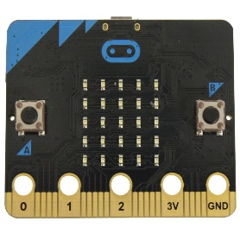

A. X

B. Y

C. Z

D. All of the above

ANSWER: C

Which of the following could be the velocity something is travelling?

A. 32.5 kph

B. 33 mph

C. 2 minutes East

D. 33.4 mph East

ANSWER: D

Which note will be played first if button B is pressed?

tune = ["C4:6", "D4:4", “C4:4”]

tune2 = ["C8:4", "E4:4", “C2:5”]

while True:

if button_a.is_pressed():

music.play(tune)

elif button_b.is_pressed():

music.play(tune2)

A. 8

B. C in octave 4

C. E in octave 4

D. C in octave 8

ANSWER: D

True random numbers are usually based on a physical element which you have no control over. Which of the following could be used to generate a true random number?

A. A number generated based upon a pattern

B. A number generated by an algorithm

C. A number generated by Python using the random number library

D. A number based on electromagnetic field measurements

ANSWER: D

In the code below, what will be displayed if reading = -40?

from microbit import *

while True:

reading = accelerometer.get_x()

if reading > 20:

display.show("R")

elif reading < -20:

display.show("L")

else:

display.show("-")

A. R

B. L

C. -

D. “-“

ANSWER: B

Jerome has tested the code below but cannot get it to work with all tests. What does he need to do to correct the error?

from microbit import *

while True:

gesture = accelerometer.current_gesture()

if gesture == "right"

display.show(Image.ARROW_E)

elif gesture == “left”:

display.show(Image.ARROW_W)

elif:

display.show(Image.SKULL)

A. Change all == to =

B. Change if gesture to elif gesture

C. Change the last elif: to else:

D. Change gesture = to gesture ==

ANSWER: C

In the code below what would be output if you change ? to breakfast?

display.show("?")

A. The microbit would display the contents of the variable breakfast

B. The microbit would display the text “breakfast”

C. The microbit would crash as it is expecting an operation to be included

D. The microbit would display an error message

ANSWER: A

Which of the following is a gesture which is not recognised by the microbit?

A. 4g

B. 3g

C. freefall

D. face up

ANSWER: A